|  |  |  |  |
| --- | --- | --- | --- |
| **Lyng Primary School Knowledge Organiser** | | | |
| **Topic:** | **Let’s Remember: World war 1**  **What countries and capital cities would I find in Europe?** | Year 2  Let’s Remember | Summer |

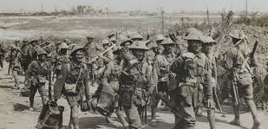

**Background information for parents and teachers**

World War I began in 1914, after the assassination of Archduke Franz Ferdinand, and lasted until 1918. During the conflict, Germany, Austria-Hungary, Bulgaria and the Ottoman Empire (the Central Powers) fought against Great Britain, France, Russia, Italy, Romania, Japan and the United States (the Allied Powers).  By the time the war was over and the Allied Powers claimed victory, more than 16 million people, soldiers and civilians alike were dead.

|  |  |
| --- | --- |
| **What Step On and Goldilocks words will I use?** | |
| **Spelling** | **Definition** |
| Country | A **country** is a unit that the world is divided into covering a particular area of land. |
| Nation | A **nation** is an individual country considered together with its social and political structures. |
| Eastern Front | The **Eastern Front** during WW1 was fought in Eastern Europe. |
| Western Front | The **Western Front** during WW1 was fought in Western Europe. |
| Capital cities | A **capital city** is where the government of a country is located. |
| Physical geography | The branch of [geography](https://www.collinsdictionary.com/dictionary/english/geography) that [deals](https://www.collinsdictionary.com/dictionary/english/deal) with the natural [features](https://www.collinsdictionary.com/dictionary/english/feature) of the earth's surface |
| Human geography | The branch of geography dealing with how human activity affects or is influenced by the earth's surface |
| Aerial images | An **aerial image** is a photograph taken from above. |
| Land marks | A **landmark** is a building or feature which is easily noticed. |

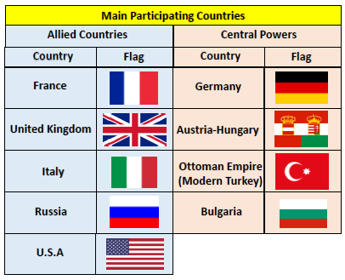

|  |
| --- |
| **Geographical skills** |
| * Ask and answer geographical questions (such as: What is this place like? What or who will I see in this place? What do people do in this place?). * Use world maps, atlases and globes to identify Europe and its countries, as well as the continents and oceans studied. * Use aerial images and plan perspectives to recognise landmarks and basic physical features. * Name, locate and identify countries and capital cities of Europe and its surrounding seas. * Use compass directions (north, south, east and west) and locational language (e.g. near and far) to describe the location of features and routes on a map. |

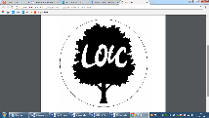

**Significant places**

* UK
* France
* Italy
* Russia
* Germany
* Austria

**Fieldwork Opportunities**

Outdoor learning in Trenches. Discuss the land use and how trenches are made.

**Our Storytelling Approach to enhance engagement**

|  |  |  |
| --- | --- | --- |
| **People:**  Young, British Soldier | **Place:**  The Western Front | **Problem:**  British Soldier being sent off for battle. |

**Key facts and locations**

**Map to be studied**

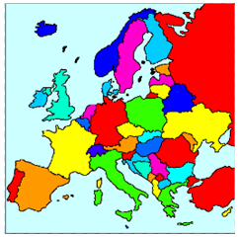

**Agreed Outcome**

A labelled map of countries involved in World War 1.

Identify key capital cities in Europe.

• World War 1 began on July 28, 1914 and lasted until November 11, 1918

• The two main sides were the Allies, which included **France, Great Britain and Russia; and Germany and Austria-Hungary**

• In total**, 30 countries** were involved in the conflict. **Italy**, once part of the Triple Alliance with Germany and Austria-Hungary, fought on the side of the Allies.

• Soldiers fought largely in **trenches** during the war, and thousands suffered from stress, known as shell-shock.

* • By the end of WW1, over 9 million soldiers had been killed, and another 21 million wounded. Over a million soldiers were killed in the infamous **Battle of the Somme** alone, including about 30,000 in just one day.

**Key Questions – sequence of learning**

* What countries were involved in World War 1?
* What are some of the European countries and capital cities?
* What was life like in the trenches for soldiers?
* What are the points on a compass?
* What are grid references on a map?
* FIELDWORK

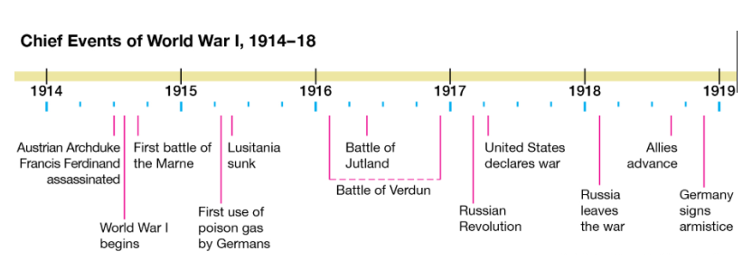

|  |  |  |  |
| --- | --- | --- | --- |
| **Lyng Primary School Knowledge Organiser** | | | |
| **Topic:** | **Let’s Remember: World war 1**  **What countries and capital cities would I find in Europe?** | Year 2  Let’s Remember | Summer |

|  |  |  |
| --- | --- | --- |
| 6. Which country did the battle of the Somme take place? | **S** | **E** |
| England |  |  |
| France |  |  |
| Germany |  |  |

|  |  |  |
| --- | --- | --- |
| 7. Which is not a capital city of the UK? | **S** | **E** |
| Paris |  |  |
| London |  |  |
| Cardiff |  |  |

|  |  |  |
| --- | --- | --- |
| 8. What is the largest country in Europe? | **S** | **E** |
| United Kingdom |  |  |
| Russia |  |  |
| Germany |  |  |

|  |  |  |
| --- | --- | --- |
| 1. Where were trenches located? | **S** | **E** |
| land |  |  |
| air |  |  |
| sea |  |  |

|  |  |  |
| --- | --- | --- |
| 1. If you look from an aerial view where are you looking? | **S** | **E** |
| up |  |  |
| down |  |  |
| left |  |  |

|  |  |  |
| --- | --- | --- |
| 1. Germany, France and Italy are all countries from which continent? | **S** | **E** |
| 1. North America |  |  |
| 1. Africa |  |  |
| 1. Europe |  |  |

**Our WW1**

**Quick Quiz**

|  |  |  |
| --- | --- | --- |
| 1. What is the name of the sea that you have to cross to get from the UK to France? | **S** | **E** |
| French Channel |  |  |
| English Channel |  |  |
| European Channel |  |  |

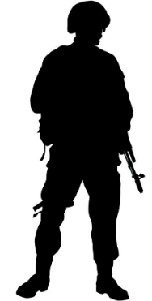

|  |  |  |
| --- | --- | --- |
| 1. How is the UK different to other European countries? | **S** | **E** |
|  |  |  |
| 1. Which country is shaped like a boot? | **S** | **E** |
| Italy |  |  |
| Germany |  |  |
| Hungary |  |  |

|  |  |  |
| --- | --- | --- |
| 1. Calais is ________ of the Somme battlefield? | **S** | **E** |
| North |  |  |
| South |  |  |
| West |  |  |